MiPlatform – Universal Smartphone/Microscope Adapter
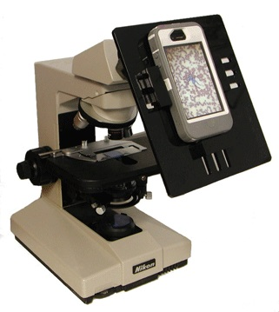  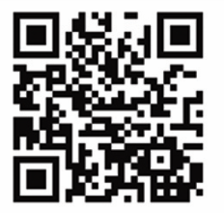  YouTube™ video featuring MiPlatform |  |   MiPlatform conveniently transforms your smartphone into an essential laboratory discovery tool. This revolutionary platform allows you to quickly and easily capture high quality photographs or movies from virtually all microscopes with nearly all smartphones.  Installation and alignment is simple because there are no optical elements. MiPlatform taps the power of your existing microscope and the precision of your smartphone camera. Adjustable grips secure your smartphone and ensure steady, optimum photography. Detach your phone when you get a call or finish for the day; the next day replace without any fine-tuning, saving time and avoiding stress. MiPlatform’s exclusive open design allows painless access to your phone’s other functions: charging ports are accessible, connect to an external screen via cable (not included) or just listen to music. The platform that holds the phone detaches from the easy- to-install mounting collar. Additional mounting collars are available.  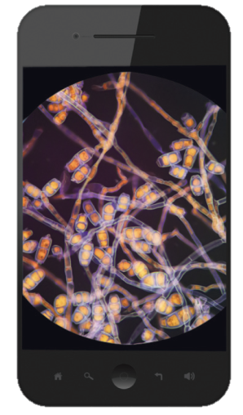  - MEDICAL RESEARCH – stimulating opportunities for researchers to instantaneously share views from the microscope in person and over the internet, document and archive results without an additional footprint or costly software  - CLINICAL APPLICATIONS – easy group viewing, simple documentation and archiving, expedient training, remote consultation  - HIGHER EDUCATION – stimulating opportunities for teacher and student to instantaneously share views from the microscope both in person and over the internet  - PRIMARY/SECONDARY EDUCATION – allows students who may have trouble looking though microscope eyepiece to see every detail  - QUALITY CONTROL AND ASSURANCE – documentation of test result images are easily and permanently retained  - RECREATIONAL – social media allows you to share your most exciting photos on-line  - ASTRONOMICAL – also ideal for photographs, video and sharing images on essentially any amateur telescope
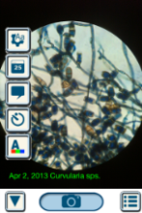 | MiPlatform App … available at itunes
 | This app provides added camera functionality with ability to date stamp or caption a photo while photographing, and directly share via Twitter, Facebook or e-mail. Print on compatible printers wirelessly. With AV cables available from Apple separately, the iPhone can be connected to a video projector or monitor for classroom use. Future updates with counting features and photographic filters. Go to - http://itunes.com/apps/MiPlatform
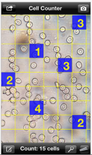 | MiCell Count App … available at itunes
MiCellCount is your simple and fun manual counting solution. Using this downloadable App you can analyze a microscope photo taken with either MiPlatform (see description below) or any imported photo. You simply choose the appropriate size grid for you to count cells, colonies on a plate, positive wells in a multi-well plate or anything else. Tap the square to count a cell and when you are done tapping, the count is totaled for you. When you are done, add comments, if necessary, and save for your records. You can zoom, scroll and change the grid size to make your counting drudgery into fun and games.
This app is not approved for clinical use.
2013 RETAIL PRICING

ItemCode
ItemName
Price

2100
MiPlatform (Platform & Collar)
$129.00

2110
MiPlatform Auxiliary Monitoring Collar [each]
$60.00

MiPlatform App
Available exclusively through the iTunes store
$2.99

MiCellCount App
Available exclusively through the iTunes store
$2.99

